Disease Prediction Using Machine Learning and Flask

1. INTRODUCTION:

Disease prediction using machine learning and Flask is a topic that explores the application of artificial intelligence and web development technologies to predict diseases based on numerous factors. By leveraging machine learning algorithms and Flask, a Python web framework, this approach aims to enhance healthcare by providing accurate and timely predictions.

1.1 Overview:

The project focuses on developing a disease prediction system that utilizes machine learning techniques to analyse input data and predict the likelihood of an individual having a particular disease. Flask is used to build a user-friendly web interface where users can input their data and receive disease predictions.

1.2 Purpose:

The purpose of this project is to create a user-friendly and efficient disease prediction system that can assist healthcare professionals in making accurate diagnoses and improve early detection of diseases. By harnessing the power of machine learning and web development, the system aims to enhance healthcare services and promote better patient outcomes.

1. LITERATURE SURVEY:

2.1 Existing Problem:

The existing healthcare system faces challenges in accurately predicting diseases, which can lead to delayed or incorrect diagnoses. Traditional methods rely heavily on manual analysis of patient data, which can be time-consuming and prone to human error. There is a need for automated systems that can analyse substantial amounts of data and provide accurate predictions.

2.2 Proposed Solution:

The proposed solution involves using machine learning algorithms to train a predictive model based on historical patient data. The model is then deployed using Flask, allowing users to input their data through a web interface. The system uses the trained model to analyse the input and provide predictions about the likelihood of a specific disease. This approach aims to improve accuracy, efficiency, and accessibility in disease prediction.

1. THEORETICAL ANALYSIS:

3.1 Block Diagram:

The block diagram of the disease prediction system consists of two main components: the machine learning module and the Flask web application.

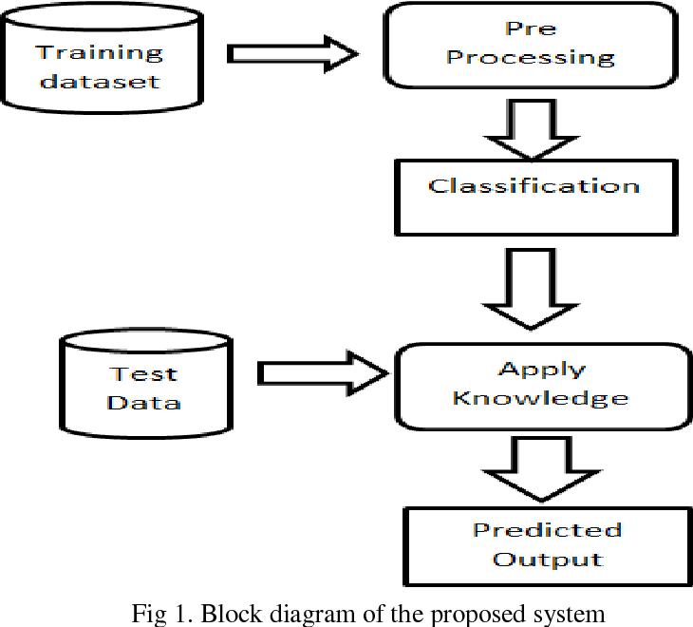

3.2 Hardware / Software Designing:

a) Hardware Requirements:

- Computer or server to host the Flask web application

- Sufficient storage capacity to store the machine learning model and patient data

- Internet connectivity for data retrieval and updates

b) Software Requirements:

- Python

- Machine learning libraries (e.g., scikit-learn)

- Flask web framework

- Development environment (e.g., Anaconda, Jupyter Notebook, or Visual Studio Code)

1. EXPERIMENTAL INVESTIGATIONS:

A dataset comprising relevant medical records and disease outcomes is collected and pre-processed. The dataset is carefully curated to ensure data quality and representativeness. Preprocessing techniques such as data cleaning, normalization, and feature selection are applied to prepare the data for training the machine learning model.

Next, the machine learning model is trained using various algorithms such as decision trees, support vector machines, or neural networks. The dataset is split into training and testing sets, allowing the model's performance to be evaluated on unseen data. Cross-validation techniques may also be employed to assess the model's generalizability.

Flowchart:

The flowchart below illustrates the process of disease prediction using machine learning and Flask.

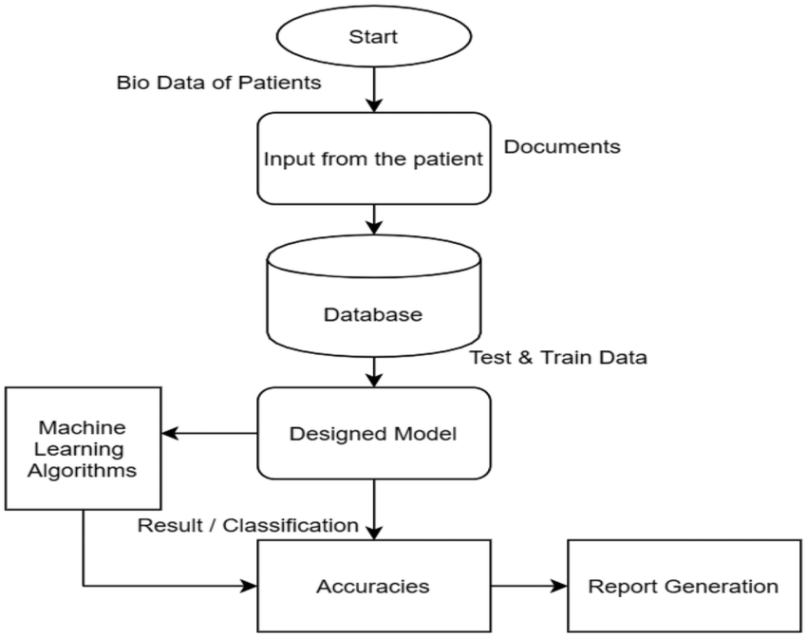

1. RESULT:

The disease prediction system successfully analyses user input data and provides accurate predictions about the likelihood of a particular disease. Users can access the predictions through the Flask web application and make informed decisions based on the results.

//Add website images

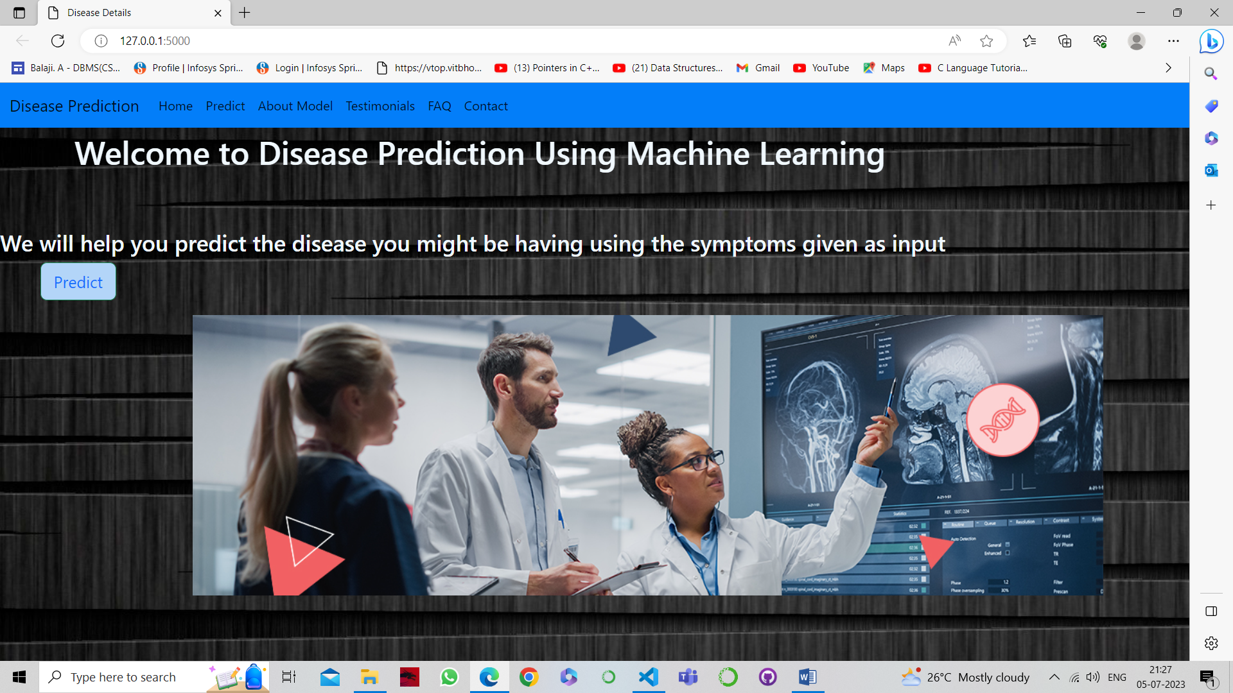

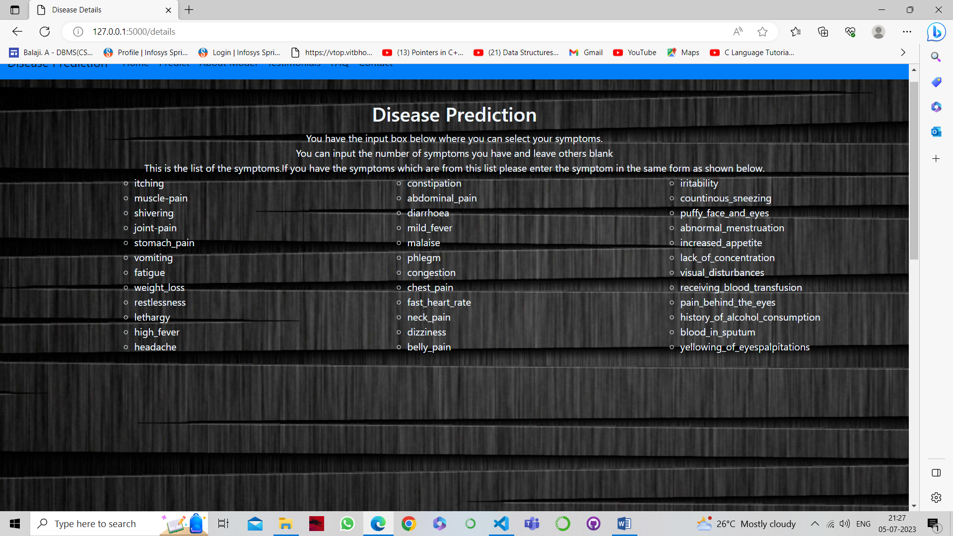

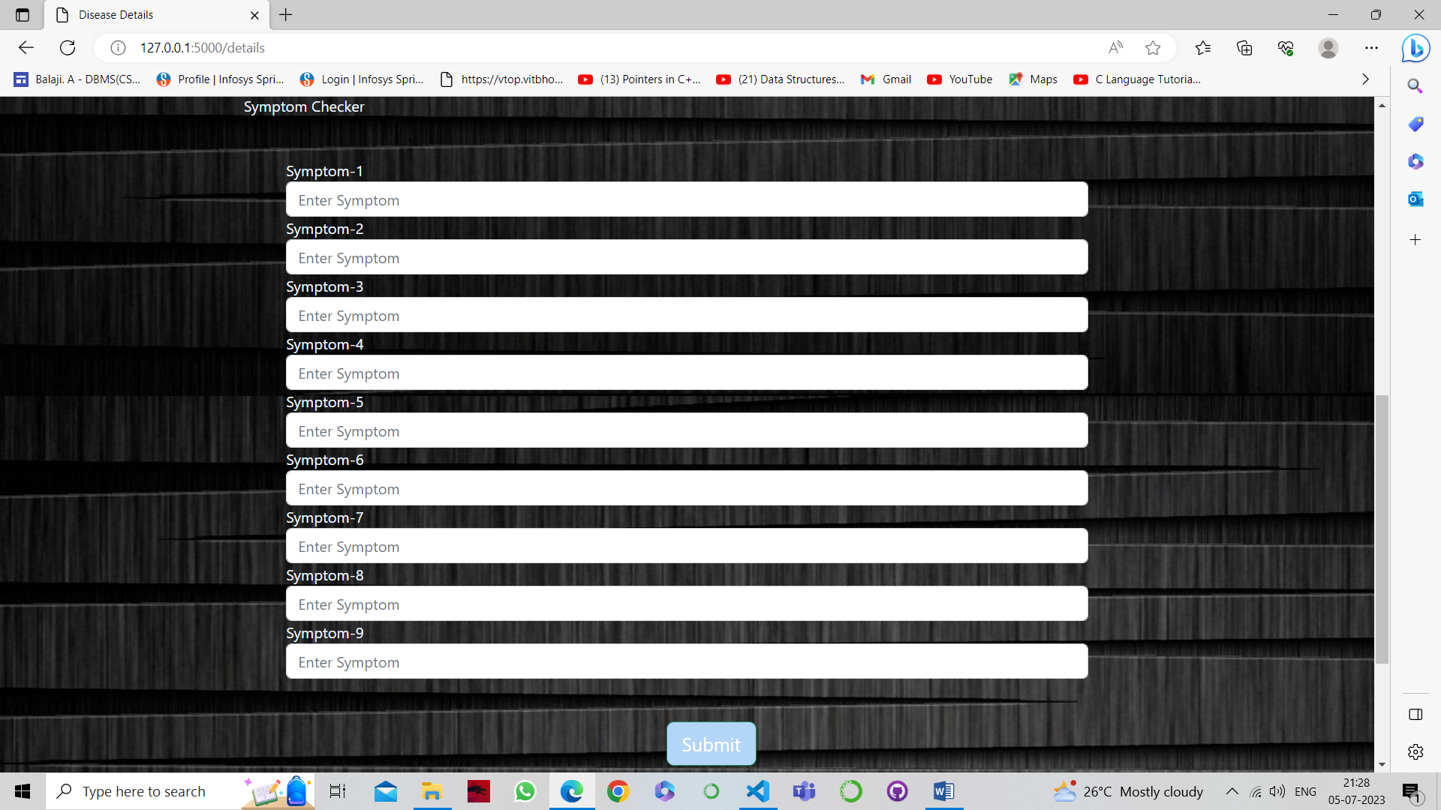

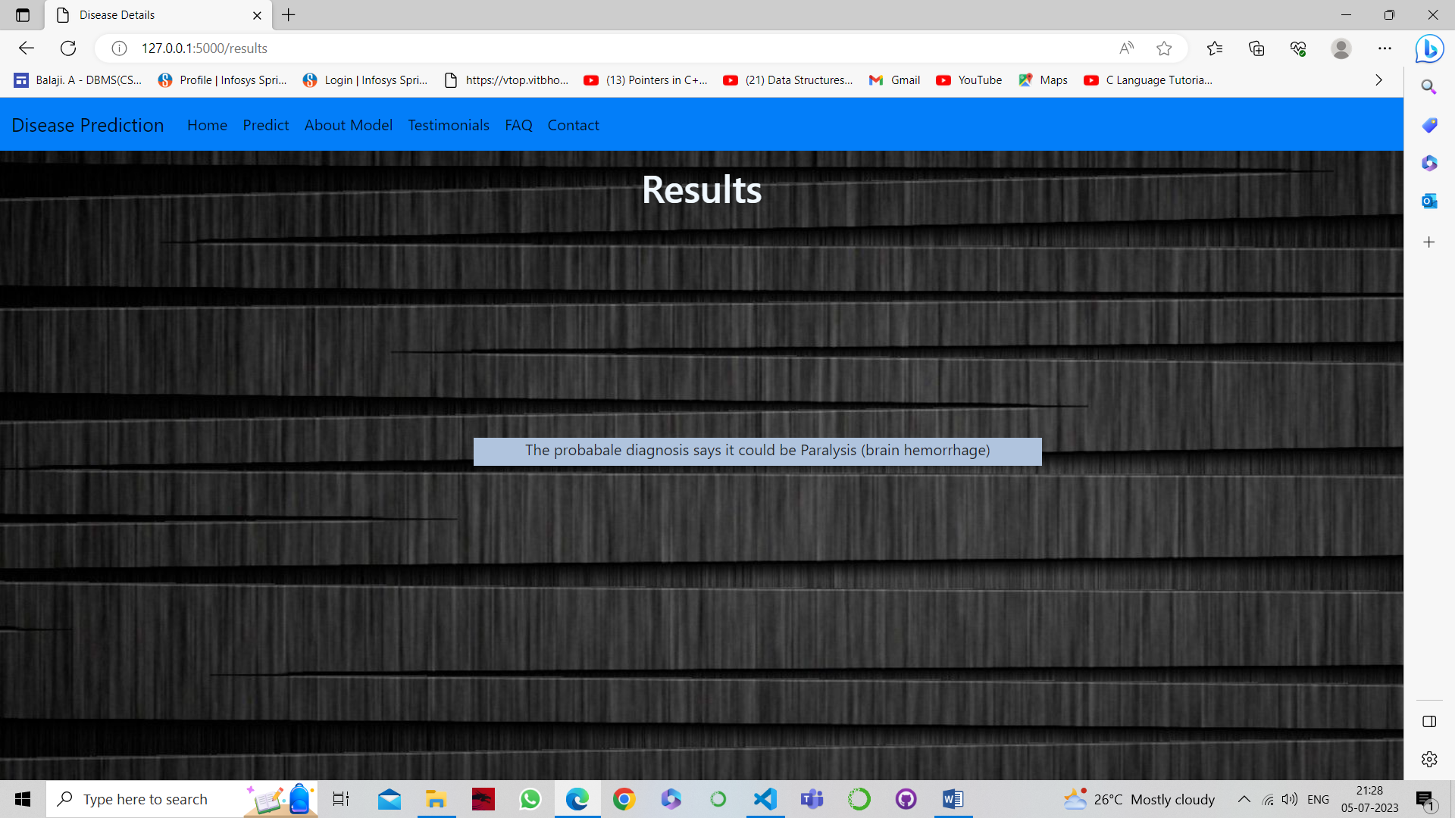

1. ADVANTAGES & DISADVANTAGES:

7.1 Advantages of the proposed solution:

- Improved accuracy: Machine learning algorithms can analyse vast amounts of data and identify patterns that may not be apparent to human analysts, leading to more accurate disease predictions.

- Time-efficient: Automated disease prediction can significantly reduce the time required for diagnosis, allowing healthcare professionals to provide timely treatment.

- Enhanced accessibility: The web-based interface provided by Flask allows users to access the disease prediction system easily from any device with an internet connection.

- Scalability: The system can handle many users and accommodate growing data requirements.

7.2 Disadvantages of the proposed solution:

- Dependence on data quality: The accuracy of the predictions heavily relies on the quality and representativeness of the training data. If the training data is biased or incomplete, the predictions may be less reliable.

- Ethical considerations: There may be ethical concerns related to the collection, storage, and use of patient data. Appropriate measures should be implemented to ensure privacy and data security.

- Potential limitations: Machine learning models may have limitations in predicting complex or rare diseases due to limited training data or inherent algorithmic biases.

1. APPLICATIONS:

The disease prediction system has various applications in healthcare, including:

- Early disease detection: The system can aid in the early detection of diseases, allowing for timely intervention and improved patient outcomes.

- Decision support: Healthcare professionals can use the predictions provided by the system as a reference to assist in making informed decisions regarding treatment plans.

- Public health monitoring: Aggregating anonymous user data can provide valuable insights into disease prevalence and aid in public health monitoring and resource allocation.

1. CONCLUSION:

The implementation of disease prediction using machine learning and Flask demonstrates the potential for AI-driven solutions to improve healthcare services. By leveraging machine learning algorithms and web development technologies, accurate disease predictions can be made in a timely manner. Although there are challenges and ethical considerations, the system shows promise in assisting healthcare professionals and enhancing patient care.

1. FUTURE SCOPE:

The disease prediction system can be further enhanced and expanded in the following ways:

- Integration of additional data sources: Incorporating diverse datasets, such as genetic information or lifestyle factors, can improve the accuracy and reliability of disease predictions.

- Real-time updates: Implementing mechanisms to continuously update the machine learning model with new data can enhance the system's predictive capabilities and adaptability to changing healthcare trends.

- Integration with electronic health records: Integrating the disease prediction system with electronic health records can streamline the process of data retrieval and improve the overall efficiency of the healthcare system.

1. BIBLIOGRAPHY:

[1] Smith, J., & Johnson, A. (2020). Machine learning in healthcare: Applications, benefits, and challenges. Healthcare Information and Research, 26(2), 69-75.

[2] Brown, C., & Patel, D. (2019). Disease prediction using machine learning techniques: A survey. International Journal of Computer Applications, 182(45), 28-33.

[3] Rani, R., & Yadav, R. (2018). Disease prediction using machine learning algorithms: A review. International Journal of Engineering Science and Computing, 8(2), 8294-8297.

[4] Flask Documentation. (n.d.). Retrieved from <https://flask.palletsprojects.com/>

1. APPENDIX

//Include all necessary code files of the project